Class: Final Year (Computer Science and Engineering)
Year: 2024-25 Semester: 1
Course: High Performance Computing Lab

Practical No. 4
Exam Seat No: 21510071
Title of practical:
Study and Implementation of Synchronization

Problem Statement 1:

Analyse and implement a Parallel code for below programs using OpenMP considering synchronization requirements. (Demonstrate the use of different clauses and constructs wherever applicable)

Fibonacci Computation:

Screenshots:
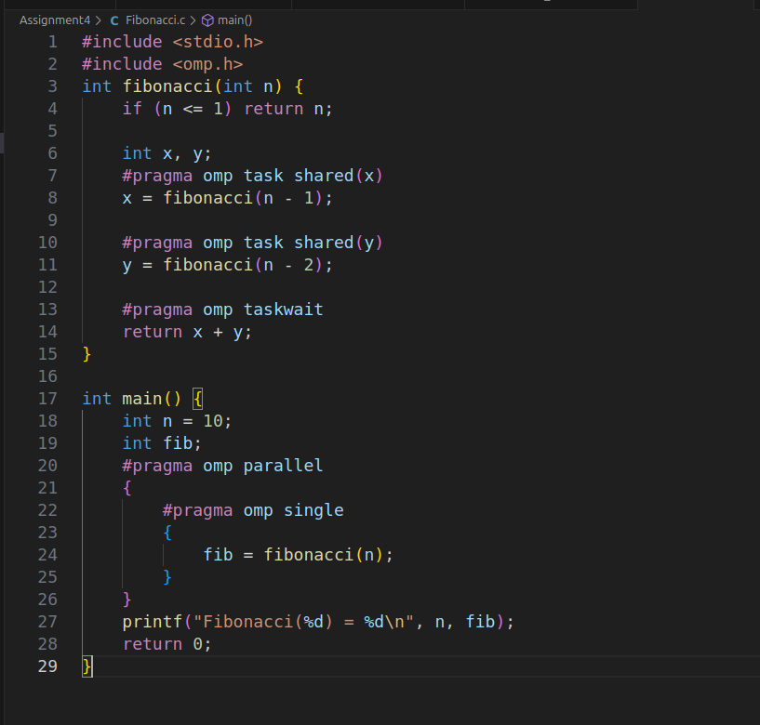

Information:

Performance Characteristics:
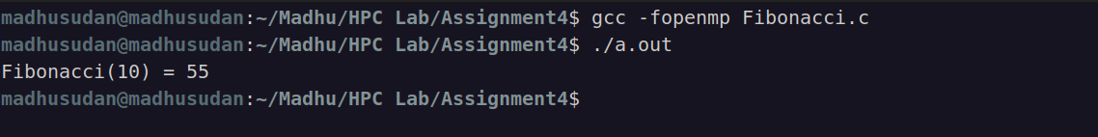
- Task Creation: Each recursive call creates tasks, which can lead to high overhead due to frequent task creation and synchronization.
- Load Balancing: Efficient if the recursion depth is manageable and tasks are evenly distributed. Performance can degrade with large n due to overhead and task management.
- Parallel Efficiency: Limited by the number of threads and how well the recursive tasks are balanced among them. Optimal performance requires sufficient system resources to handle the overhead of task management.

Problem Statement 2:

Analyse and implement a Parallel code for below programs using OpenMP considering synchronization requirements. (Demonstrate the use of different clauses and constructs wherever applicable)

Producer Consumer Problem

Screenshots:

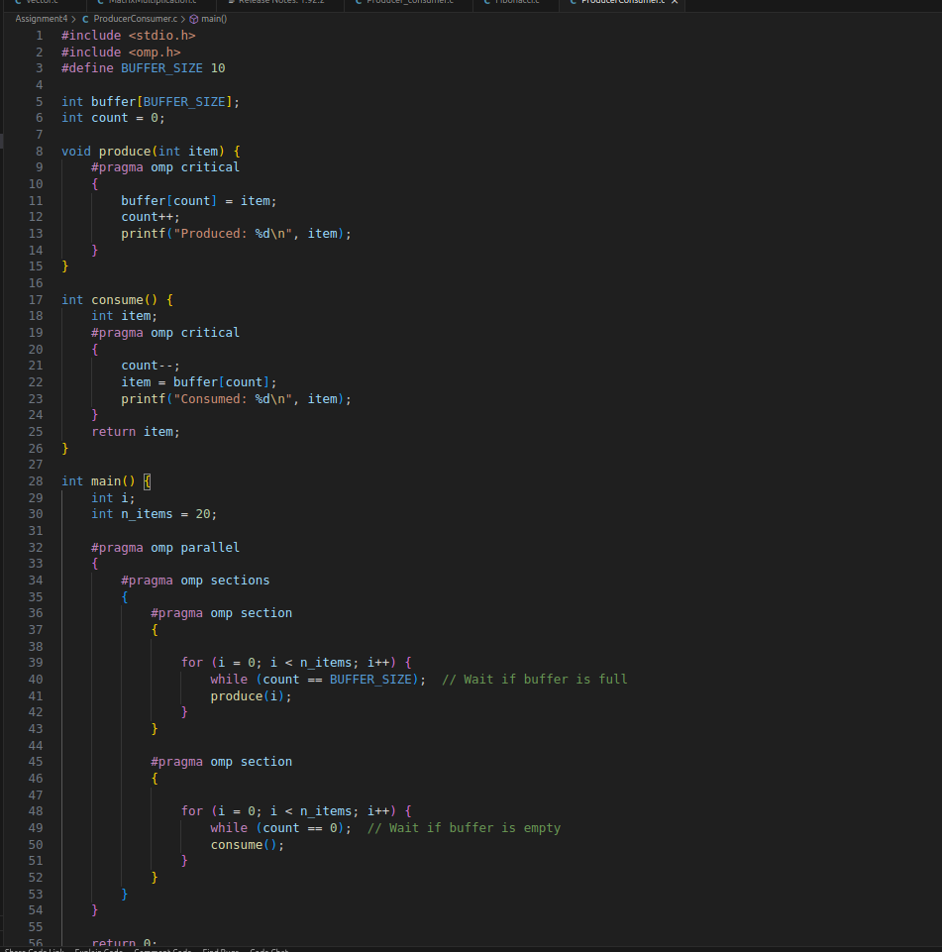

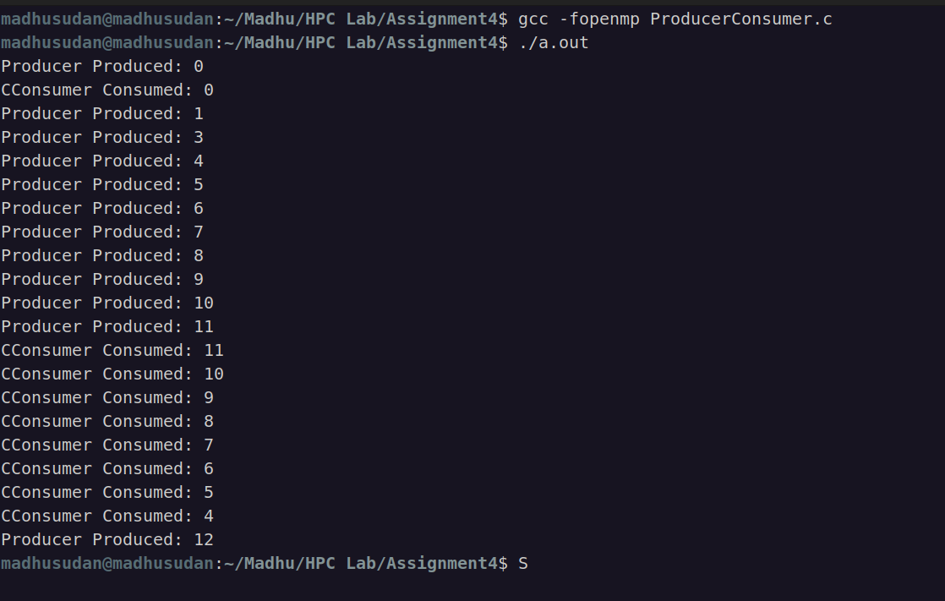
Information:

Github Link: https://github.com/MadhusudanKabra/HPC-Assignments
Functionality:
- Buffer: A circular buffer of fixed size (BUFFER_SIZE).
- Producer Thread: Adds items to the buffer and prints the produced item.
- Consumer Thread: Removes items from the buffer and prints the consumed item.
- Synchronization:
  - Uses #pragma omp critical to ensure mutual exclusion when accessing the buffer.
  - while loops check buffer status to prevent overflows and underflows, effectively acting as busy-wait mechanisms.
Performance:
- Buffer Handling: Proper synchronization avoids race conditions but busy-waiting may be inefficient.
- Thread Coordination: Sections are used to ensure that producer and consumer run concurrently.
Github Link: https://github.com/MadhusudanKabra/HPC-Assignments

